**Exercise 02: Mooring system forces and stiffnesses**

Task: Calculate force-displacement relations for catenary and taut mooring systems

Provided:

* m-function to solve fairlead forces for an inelastic catenary line
* m-script that derives mooring system 6DOF forces for an arbitrary displacement

1. *Determine & plot x-F relation for a single catenary mooring line of the SWE TripleSpar concept and tensioned mooring line of DeepCwind TLP*
2. *Determine & plot variation in loads in surge, heave and pitch, due to motion in surge, heave, pitch, yaw for the SWE TripleSpar concept and DeepCwind TLP*
3. *Determine an equivalent linear stiffness matrix for the SWE TripleSpar mooring system about the static equilibrium position.*

**Stuttgart Wind Energy TripleSpar mooring system**

The TripleSpar mooring system consists of three radially spread catenary lines. The design water depth is 180m and the fairlead connections are extended from the columns such that the distance from the platform centerline is 54.48m. The platform and mooring system are oriented in such a way to have two ‘upwind’ lines and one ‘downwind’ line, implying that one line is aligned to the zero degree wind/wave heading. Below are some illustrations are relevant properties. See definition report [1] for further details.

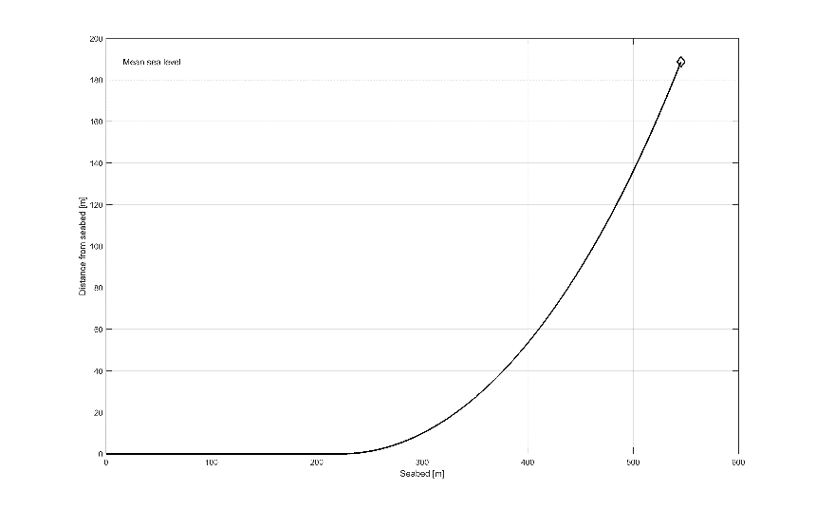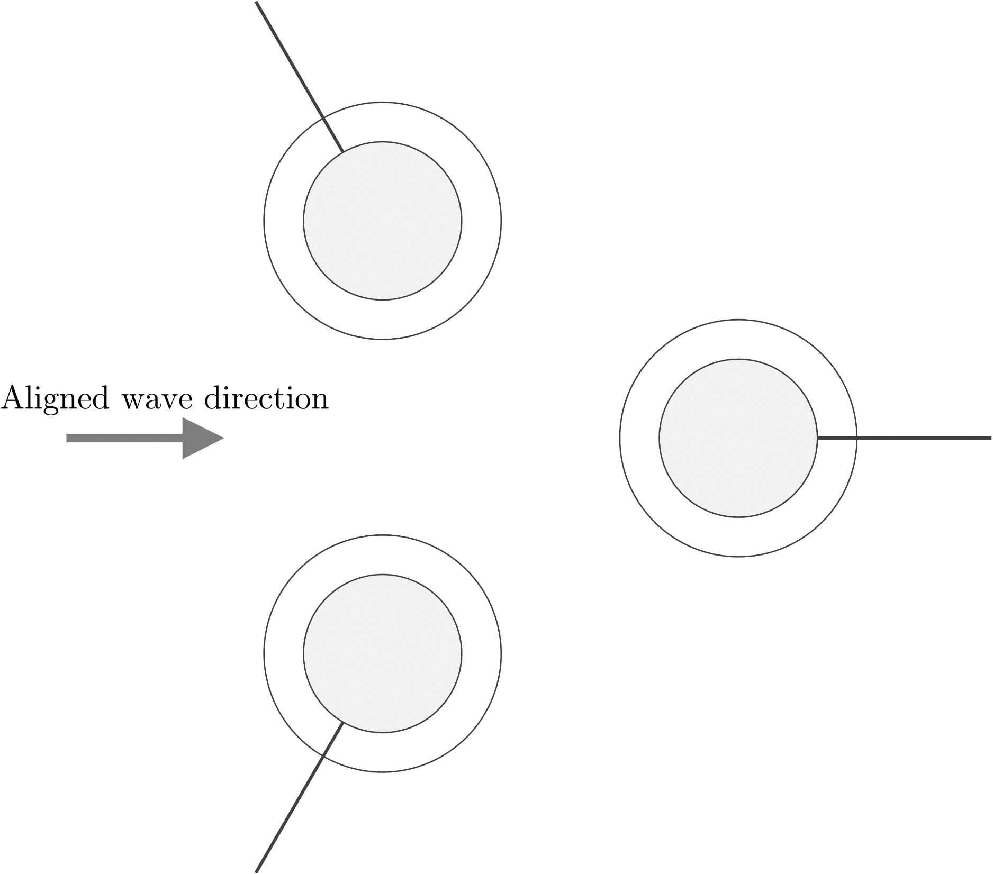

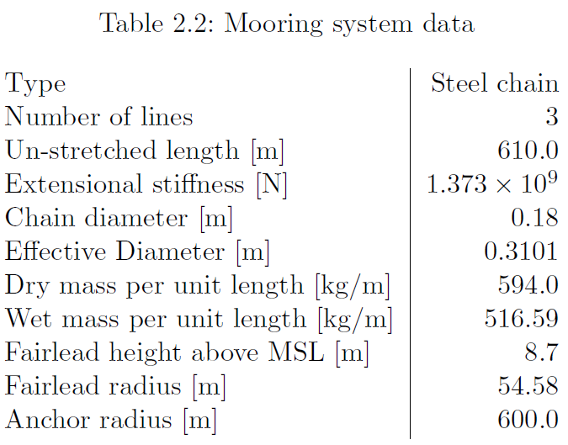

**DeepCwind TLP mooring system**

The DeepCwind TLP mooring system consists of three vertical tendons, each connected to one of the platform pontoons. The platform and mooring system are illustrated below, along with relevant properties.

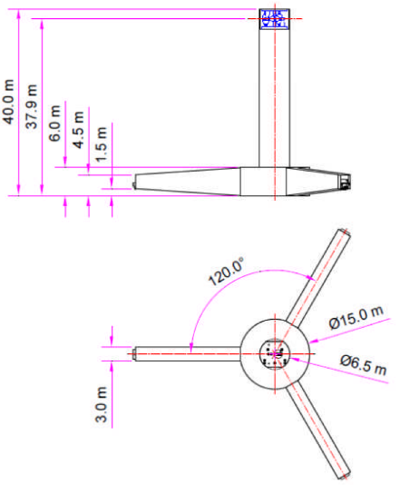See [2] for further details.

